Final Program
class Automobile:
def __init__(self):
self.__make = " "
self.__model = " "
self.__color = " "
self.__year = 0
self.__mileage = 0

def add_vehicle(self):
try:
self.__year = int(input("Please enter year: "))
self.__make = input("Please enter make: ")
self.__model = input("Please enter model: ")
self.__color = input("Please enter color: ")
self.__mileage = int(input("Please enter mileage: "))
except ValueError:
print('Please re-enter the right information!')

def __str__(self):
return ('%d %s %s %s %d' %
(self.__year, self.__make, self.__model, self.__color,
self.__mileage))
vehicle_record = []

def edit(vehicle_record):
pos = int(input('Please enter the position of the vehicle to edit: '))
new_vehicle = car.add_vehicle()
new_vehicle = car.__str__()
vehicle_record[pos-1] = new_vehicle
print('Vehicle was edited')

user=True
while user:
print ("""
1.Add a Vehicle
2.Delete a Vehicle
3.View Inventory
4.Edit Inventory
5.Save Inventory into Text file
6.Quit
""")
Options=input("What option you like to choose? ")
if Options=="1":
car = Automobile()
car.add_vehicle()
vehicle_record.append(car.__str__())

elif Options=="2":
try:
for i in vehicle_record:
position=int(input('Please enter position of vehicle to remove: '))
vehicle_record.pop(position)
print('Successfully removed vehicle ')
except:
print('Please re-enter a valid number for the position: ')
elif Options=="3":
print(vehicle_record)
elif Options=="4":
edit(vehicle_record)

elif Options=='5':
f = open('vehicle_inventory.txt', 'w')
f.write(str(vehicle_record))
f.close()
else:
print('Please try again!')
# Add

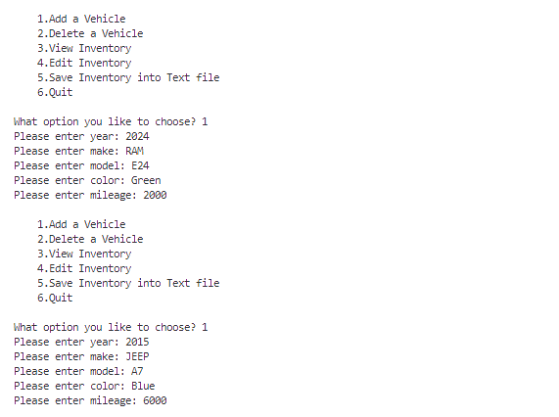
# Update
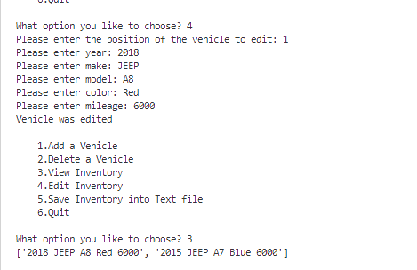
# Remove
